5th Annual Landon’s Legacy
Golf Tournament
Sponsor Sheet

Sponsor Name: Company Name___________________________________
Mailing Address: __________________________________________
Email: Phone: Payment form _____
Hole Sponsorship ($500) __________________ Other sponsorship amount__________________________
Pin Sponsorship ($750) Company name on Flag ( 36 Available)________________________________________
Major Sponsor ($2000) Banner With Logo at Golf Event _______________________________________________________
Other Donation item____________________________________________________________________________
Please mail your completed form with payment by April 25th to:
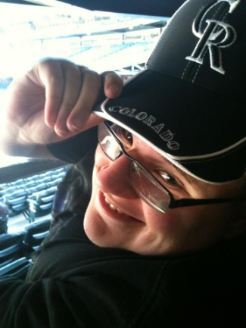
Landon’s Legacy Foundation
P.O. Box 80542
Billings, MT 59108
Thank you!!
If you have any questions regarding the tournament you may contact:
The golf committee
Greg Kemmis 671-3590 Rhett Hightower 839-3273
Murray Brumwell 855-6614 Shane Heigis 698-9588
Scott Roby 861-4406 Greg Kemmis 671-3590
Rob Smith 698-5733 Brian Hafner 696-2264
www.landonslegacy.com

